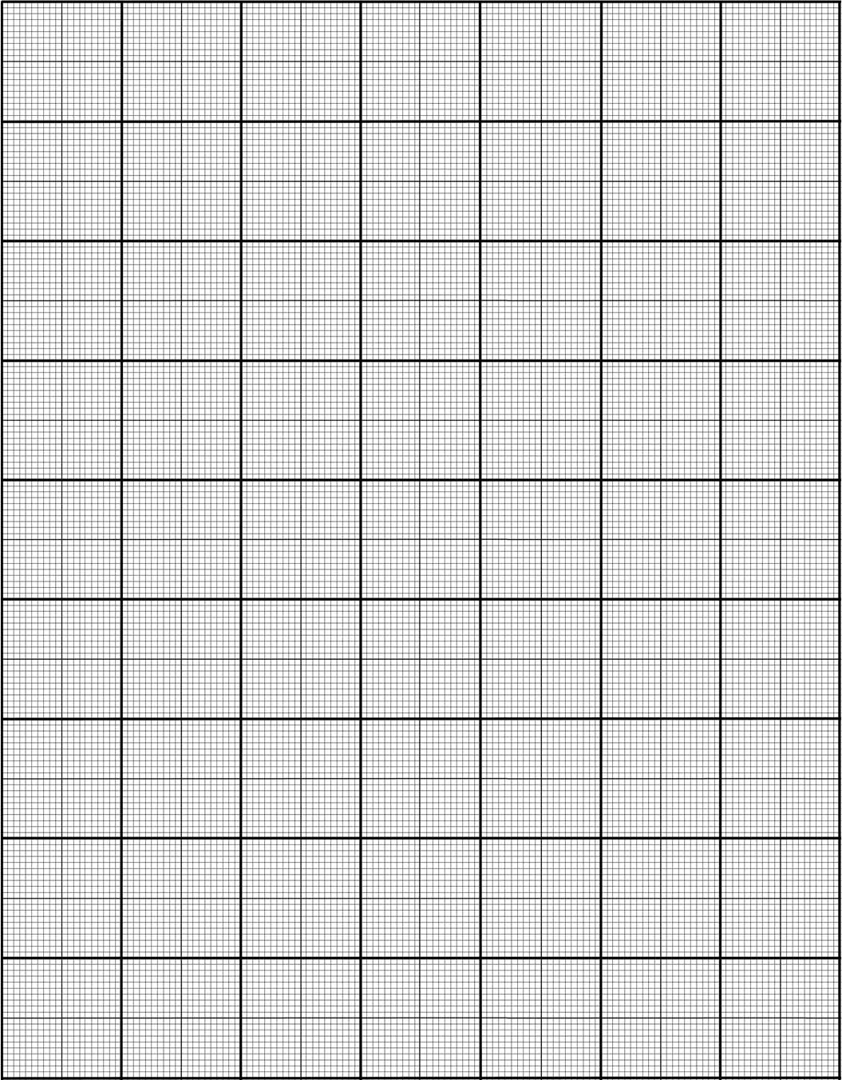

20 square per inch graph paper suitable for photographic sensitometry graphing applications – Andrew Davidhazy – andpph@rit.edu

